BUZZER

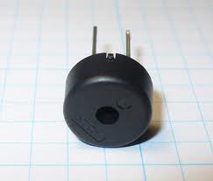

Electrical Specifications:

• Sound Pressure Level: 80dB min./30cm./9VDC
• Oscillating Frequency: 2.5 ± 0.5KHz
• Current Consumption: 8mA max./9VDC
• Operating Voltage: 3 to 30VDC

Materials:

• Tone: Continuous
• Case: PBT
• Lead Wire: UL1095 28AWG
• Weight: 7 grams 254-PB511
Piezoelectric Buzzer
(Built-In Drive) Mechanical Specifications:

• Operating Temperature: -30°C to +70°C
• Storage Temperature: -40°C to +85°C

